Espionage

Requirements: piecepack

Players: 4

Premise: You are the head of the central intelligence agency of your respective kingdoms. You are trying to infiltrate the neighboring kingdoms to obtain their precious secrets. Enemy spies may block your path, but using unconventional means you can steal information from them allowing you to advance closer to your objective faster than you could alone(diagonal jump). Use strategy to maximize your own progress towards the end goal while also making sure to hinder other organizations in their own conquest for information. Who will be the first to learn all of their enemies secrets?

Goal: Place all of your spies(tokens) in the enemy's cities(flags).

Win condition: First person to place all of their tokens onto any enemy flags wins.

Setup:
-Separate the 1 and null tiles for each suit.
-Create a 4x4 board from all remaining tiles, making sure that all of the tiles are flipped face down.
-Place all tokens for your suit on your 1 tile.
-Place each flag on their own individual corner of the board.
-The person that starts is decided by die roll, and the turn order will continue clockwise around the table.

Play order: Place a token from your “1 tile” in one of the three empty spaces around your flag(this consumes a turn).
For every turn after you may do one of the following:
-Move one of your tokens in any cardinal direction as long as there is no other token on that space.
-Place a token from your “1 tile” in one of the three empty spaces around your flag(this consumes a turn).
-Jump diagonally over ally and/or enemy tokens onto an empty square(jumps can only be done over one token at a time, but can be done continuously if available).
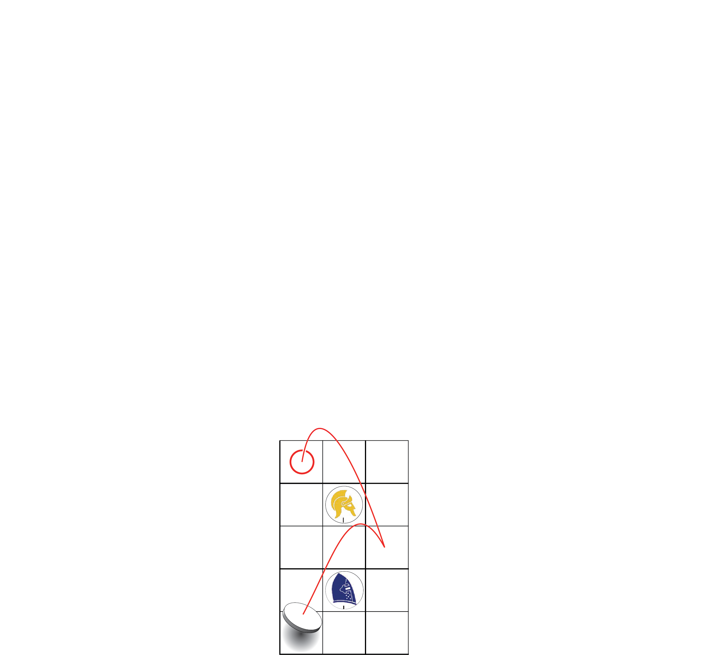

Other Mechanics:
-Once one of your tokens has landed on an enemy flag your token is removed from play and placed on your “null tile”.
-you may only have one of your own tokens in your own kingdom tile at a time.
-Should an enemy token stay in your kingdom tile for more than one round on your turn you may choose to return a tile that meets that requirement to the owner’s “1” tile.

-At the beginning of their turn, the only person with the least amount of completed spy infiltrations can turn any tile that is not a corner tile 90 degrees before continuing their turn as per usual (this ability is removed as soon as said person meets the next lowest player’s infiltration count). You can gain this ability an infinite number of times but can only be used once a turn.
-You many not jump diagonally over another token if the space beyond it is already occupied.
-You cannot go outside of the board by moving in any way.

